DAT 510 uCertify Lab Activity Worksheet

Overview
This course uses uCertify virtual labs to practice working with the techniques and tools covered in the module learning. This lab activity worksheet will assist you in organizing your work and submitting the assigned labs throughout the term. Please note that the number of labs assigned in each module may vary, so adjust your uCertify Lab Activity Worksheet accordingly. Replace all bracketed text in this worksheet with the appropriate responses.

Instructions
For each lab assigned in the module, you must:

- Save a copy of the uCertify Lab Activity Worksheet using the following naming convention, replacing the bracketed text: DAT_510_Module_[Number]_uCertifyLabActivity_[First Initial, Last Name].docx
- Follow the instructions in uCertify to complete all aspects of each lab. Be sure to follow each step carefully and thoroughly test your work.
- Take screenshots of the completed labs using the uCertify snipping tool. Ensure your name and the lab number are visible. Add the screenshots to the Lab Screenshots section below.
- Answer the lab reflection prompts provided below.
- Save and submit your completed worksheet in Brightspace to be graded by your instructor.

Module Labs

7.6.2 Training a Logistic Regression Model
7.6.4 Training an SVM Classification Model
7.6.5 Training a Naïve Bayes Model
7.6.6 Training Classification Trees and Ensemble Models

Lab Screenshots

7.6.2 Training a Logistic Regression Model
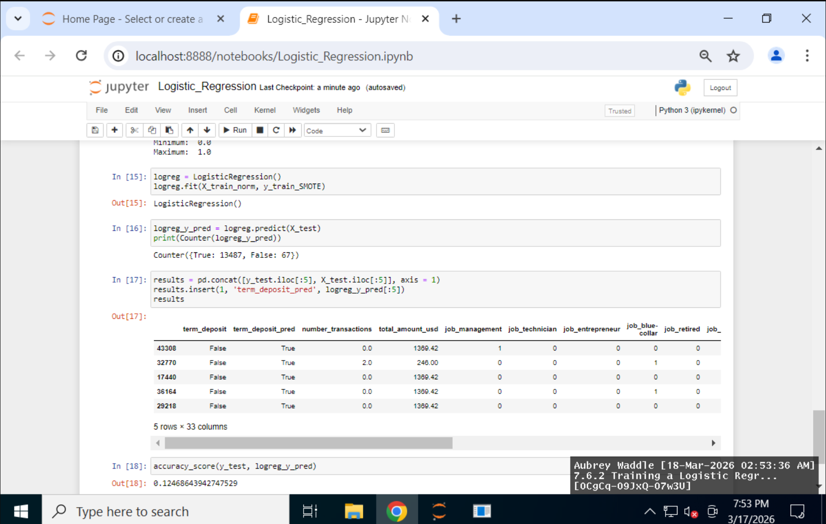
7.6.4 Training an SVM Classification Model
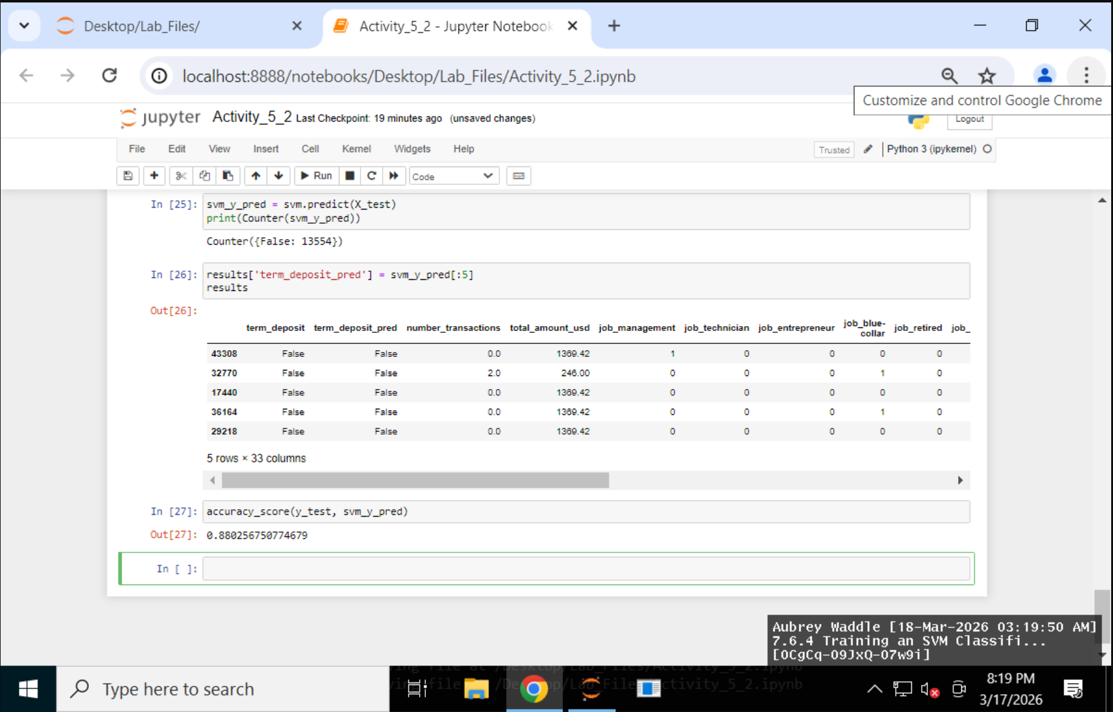

7.6.5 Training a Naïve Bayes Model
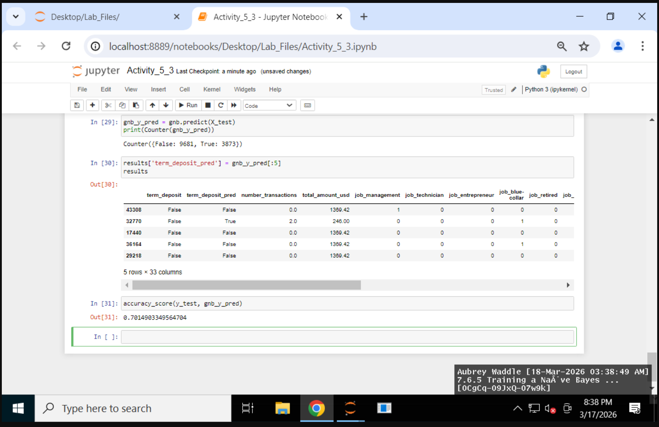
7.6.6 Training Classification Trees and Ensemble Models

Lab Reflection

7.6.2 Training a Logistic Regression Model
The objective of this laboratory exercise was to construct a Python-based categorization algorithm utilizing existing technological resources. The implementation involved the application of Scikit-learn for model development and the utilization of Pandas and NumPy for data manipulation. The dataset was first loaded and then scrutinized, with an evaluation of data types and distributions following. The data was then divided into training and testing subsets, and the Synthetic Minority Over-sampling Technique (SMOTE) was utilized to mitigate class imbalance. Data normalization was performed using MinMaxScaler, after which a logistic regression model was trained. This study highlighted the significance of scaling and balancing during the preprocessing stages. This investigation concentrated on data processing subsequent to exploration, distinguishing it from prior laboratory-based investigations. These methodologies prove advantageous in marketing and risk assessment, particularly in forecasting term deposit subscription rates. Our workflow is applicable to data analysts and scientists engaged in the development and validation of predictive models. Consequently, business stakeholders, irrespective of their technological proficiency, can leverage precise models and projections to inform their decision-making processes.

7.6.4 Training an SVM Classification Model
The laboratory continued to improve classification accuracy by training and testing a Support Vector Machine (SVM) model. To ensure consistent methods, the same pretreatment steps were used for all models. These steps included scaling the data and using a training set balanced with SMOTE. The main change was switching from logistic regression to SVM and looking at the results. After training the model, which was much better than before, I made predictions and checked how accurate they were. That showed that even with the same data and preparation, the choice of model can change the results.
These classification techniques prove valuable in marketing initiatives, fraud detection, and anticipating customer behavior. Data analysts and scientists typically employ preprocessing, training, forecasting, and evaluation as integral stages when constructing models. The accuracy of forecasts and classifications directly benefits business stakeholders, who rely on data-driven decisions, even while the technical processes unfold in the background.

7.6.5 Training a Naïve Bayes Model
In this lab, we built and tested a Naïve Bayes classification model, which is a new way to look at our old models. I used Pandas and scikit-learn again, worked with the SMOTE-balanced dataset, and made predictions on the test set. One big difference was that the workflows for the models were the same, but the results were different. The Naïve Bayes model was less accurate than the SVM model, which shows how important data and assumptions are when choosing a model.
These strategies are great for quickly and easily sorting through large amounts of data. Naïve Bayes is often used to find spam and divide customers into groups because it is simple and quick. Data analysts and scientists often train, predict, and evaluate models to help business teams make better decisions.

7.6.6 Training Classification Trees and Ensemble Models
The classification process in this laboratory study employed decision trees, random forests, and XGBoost ensemble models. The analysis, which used Pandas and scikit-learn, involved training on a dataset balanced with SMOTE. This was followed by an evaluation of how accurate the predictions were. However, the models were somewhat difficult to understand. In contrast, visualizing the decision tree provided a clearer view of how the model made its decisions. I discovered that ensemble models, such as random forest and XGBoost, consistently outperformed other approaches. This highlights the accuracy gains achievable by leveraging multiple models.

